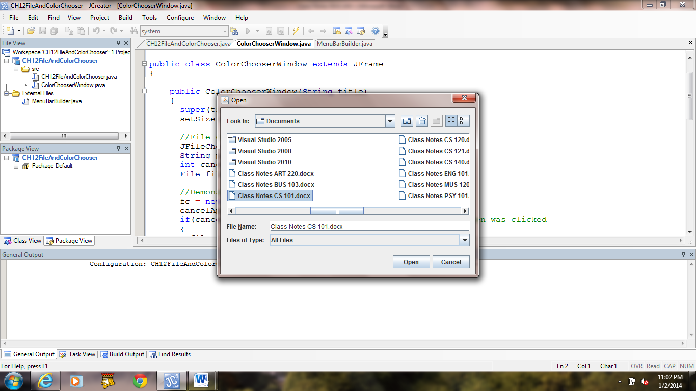 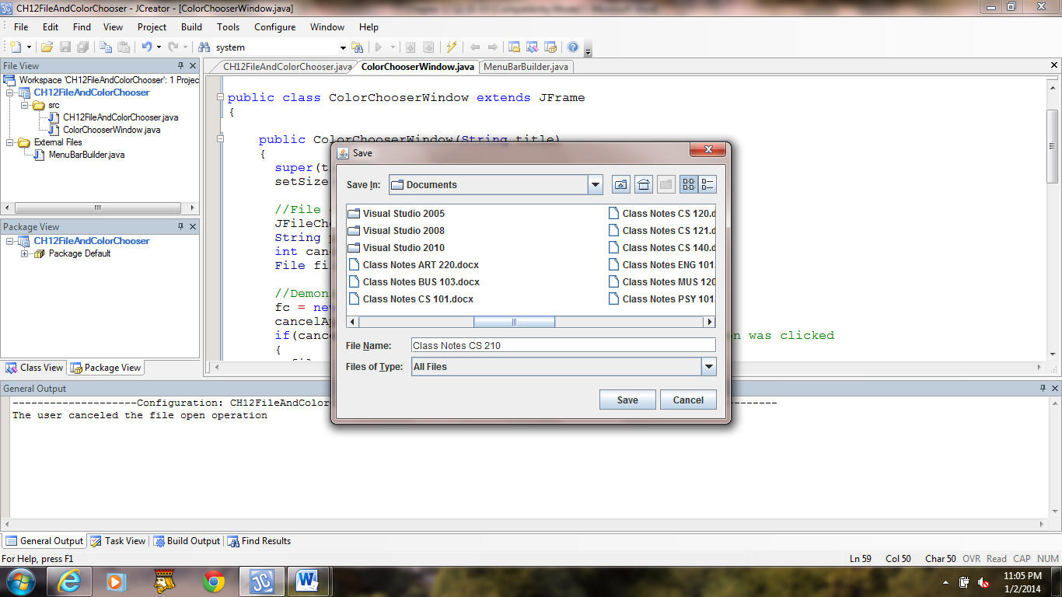

**a) b)**

**Figure 12.21 File chooser Open and Save dialog boxes.**